Nano WIRELESS N USB ADAPTER 300Mbps
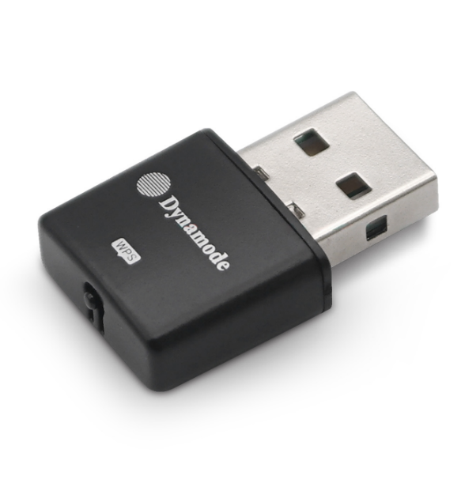
WL-700N-XSX

Description
The new WL-700N-XSX is your ideal partner for Notebook, Netbook and Macbook Computers. Featuring the new Dynamode Nano Wireless ASIC processor allows for one of the most compact Wireless 802.11n devices on the market. Fully compatible with Windows", MAC OS X"M and Linux"M, the WL-700N-XSX is compact enough so that it can be used as a direct replacement fo your internal Wireless device and as such will not come
loose when connected to a portable computer when enclosed in a Laptop bag for example. Using the latest Wireless Encryption including WPA2, 802.1x and WPS for trouble-free Wireless Encryption, the WL-700N-XSX is ideal for all your mobile, next generation mobile needs.

Features
●802.11n, 802.11g compliant WiFi
●Plug n' Play USB2.0 connection
●Supports multiple frequencies for a better connection
●Auto detects Wireless connection speeds
●Supports Soft Access Point Mode
●Supports WPA2, WPS and legacy Encryption modes
●Ultra Compact design - 'can be left as a permanent attachment for Notebooks'
●Ideal for Windows 1 0TM, Windows8"M, Windows7TM, MAC 0S XTM and LinuxTM

Specifications
- Frequency Range: 2.412GHz~2.4835GHz
- Maximum Output Power: 18dbm
- Input Voltage Range (VAC): 5V
- Output Voltage Range(VDC): 1.5V/3.3V
- Speed 11b: 11 Mbps/5.5 Mbps/2 Mbps/1 Mbps
- Speed 11g: 54 Mbps /48 Mbps /36 Mbps /24 Mbps/18 Mbps/12 Mbps/9 Mbps/6 Mbps
- Speed 11n: 40M:300Mbps/130Mbps/117Mbps/104Mbp/78Mbp/52Mbp/39Mbp/26Mbp/ 13Mbp
20M:65Mbp/58.5Mbp/52Mbp/39Mbp/26Mbp/19 .5Mbp/13Mbp/6.5Mbp
- Max. Consumption: 0.6W
- Operating Temperature: 0℃ ~ 40℃
- Storage Temperature: -40℃~70℃
- Operating Humidity: 10%~ 90% RH Non-condensing
- Storage Humidity: 5% ~ 90% RH Non-condensing

